|  |  |  |  |
| --- | --- | --- | --- |
| **VEMA Accident Report** | | MPI Claim Number  MPI Claim Number | MPI Adjuster Name and Phone (if known)  MPI Adjuster Name (if known) |
|  | | Unit Number  NNNNN | Date of Accident  MM/DD/YY |
|  | | Location  Accident Location | |
| If you’re in an accident . . .   1. Call Police if:  * A person is injured or there is a fatality. * Your vehicle has been vandalized or subject to a hit and run or theft. * The other driver is uninsured or driving with a suspended license. * The other driver is impaired. | 1. Call MPI at 204-985-7000 or Toll-Free 1-800-665-2410 (outside of Winnipeg) to open a claim. Record your claim number above. 2. Call VEMA at 1-800-363-6693 to report your accident. 3. Send a copy of this form and any supporting pictures to VEMA  Mail: 626 Henry Ave., Winnipeg, Manitoba R3A 1P7  Fax: 204-957-1109 Email: vemainfo@gov.mb.ca (forms are available at www.vema.gov.mb.ca) 4. If applicable, forward copies of your completed form to your insurance officer, supervisor or appropriate organization contact | | | |

1. Organization

|  |  |  |  |
| --- | --- | --- | --- |
| Organization/Branch  Organization / Branch | | VEMA Customer Number  Customer Number | |
| Address  Full Address including Postal Code | | | |
| Phone  204-NNN-NNNN | Fax  204-NNN-NNNN | | E-mail  user@gov.mb.ca |

1. VEMA Vehicle

|  |  |  |
| --- | --- | --- |
| VEMA Unit Number  NNNNN | License Plate Number  ABC123 | Make/Model  Make and Model |

1. Driver

|  |  |  |  |  |  |
| --- | --- | --- | --- | --- | --- |
| Name  Driver Name | | Driver’s License Number  LL-LL-LL-LNNNLL | | Driver’s License Expiry Date  MM/YY | |
| Day Phone  (204) - NNN-NNNN | Evening Phone  LL-LL-LL-LNNNLL | | Fax  LL-LL-LL-LNNNLL | | E-mail  user@server.name |
| Name of Immediate Supervisor  Name of Supervisor | Phone Number of Immediate Supervisor  (204) - NNN-NNNN | |  | |  |

1. Occupants – Total Number of Occupants: _ NN _ *(not including driver)   
   (Please attach a separate sheet if more than one occupant was involved)*

|  |  |  |  |  |
| --- | --- | --- | --- | --- |
| Name  Occupant Name | | Address  Full Address including Postal Code | | |
| Day Phone  (204) NNN-NNNN | Evening Phone  (204) NNN-NNNN | | Fax  (204) NNN-NNNN | E-mail  user@server.name |

1. Other Vehicles and Drivers – Total Number of Vehicles Involved:  NN *(including your VEMA vehicle)  
   (Please attach a separate sheet if more than two vehicles were involved)*

|  |  |  |  |  |  |
| --- | --- | --- | --- | --- | --- |
| License Plate Number  ABC 123 | | Province/State of Plate  Manitoba | | License Expiry Date  MM/YY | |
| If Not Manitoba Plates—Name of Insurance Company  Name of Insurance Company | | If Not Manitoba Plates—Policy Number  Policy Number | | If Not Manitoba Plates—Name of Agent and Address  Name of Agent and Address | |
| Year and Make  Year and Make | | | Model  Body Type: Sedan, Mini Van, etc. | | |
| Driver’s Name  Driver Name | | Driver’s License Number  LL-LL-LL-LNNNLL | | Driver’s License Expiry Date  MM/YY | |
| Address  Other Driver's Full Address with Postal Code | | | | | |
| Day Phone  (204) NNN-NNNN | Evening Phone  (204) NNN-NNNN | | Fax  LL-LL-LL-LNNNLL | | E-mail  user@server.name |
| Vehicle Owner’s Name (if not Driver)  Name of Owner | | Address  Other Vehicle Owner's Full Address with Postal Code | | | |
| Day Phone  (204) NNN-NNNN | Evening Phone  (204) NNN-NNNN | | Fax  LL-LL-LL-LNNNLL | | E-mail  user@server.name |

1. The Accident

|  |  |  |  |  |  |
| --- | --- | --- | --- | --- | --- |
| Date  MM/DD/YY | Time (AM/PM)  NN:NN AM/PM | | Location  Location of Accident | | At the time of the accident was the vehicle being used for: (click to mark)  Business  Personal use |
| Light Conditions  Dawn, Day, Dusk, Dark | Weather at Time of Accident  Weather, clear, cloudy, rain, snow, fog, ice | | Type of Road Surface  Road Surface | | Road Condition  Road Condition |
| Name of Witnesses (other than occupants)  Name<s> of Witness<es> | | Witness Phone  (204) NNN-NNNN | | Witness Address  Witness's Full Address with Postal Code | |
| Had You Consumed any Drugs or Alcohol? (Click to mark box)  Yes  No | | If so, How Much  Quantity of drinks and type | | When  When Consumed | |
| Did the Other Driver Appear to Have Been Impaired?  Yes  No | | Give any Details  Details | | | |
| Direction of Vehicle  Direction | On What Road?  Name of Road | | What Side of Road?  Side of Road | | Speed  NNN km/h |
| Direction of Other Vehicle  Direction | On What Road?  Name of Road | | What Side of Road?  Side of Road | | Speed  NNN km/h |
| What Traffic Signals Were Present?  Traffic signals present | | | | | |
| Did you Give A Warning Signal?  Yes  No | | What Kind?  Kind of Warning | | Which Lights Did You Have On (if any)?  Lights on | |
| Did the Other Driver Give A Warning Signal?  Yes  No | | What Kind?  Kind of warning | | Did the Other Driver Have their Headlights On?  Yes  No | |
| Has the Accident been Reported to Police?  Yes  No | | Did Police Attend the Scene of the Accident?  Yes  No | | Name of Police Force  Police Force Name | |
| Police Officer’s Name  Officer's Name | | Police Phone  (204) NNN-NNNN | | Police File Number  File Number | |
| Have the Police Charged Anyone?  Yes  No | | Name of Person Charged  Name Charged Person | | Nature of Charge  Nature of Charge | |

1. Injuries and Damage  *(please attach a separate sheet if you require more room.)*

|  |
| --- |
| Nature of Damage to other Vehicles  Nature of Damage - other vehicle |
| Nature of Injuries to Drivers or Occupants  Nature of Injuries |
| Nature of Damage to Unit  Nature of damage to Unit |

1. Driver’s Detailed Description of How Accident, Loss or Mechanical Damage Occurred

|  |  |
| --- | --- |
| Driver’s Detailed Description of How Accident, Loss or Mechanical Damage Occurred | |
| State Cause of Accident  State cause of Accident | |
| Driver Signature | Date  MM/DD/YY |

1. VEMA USE ONLY

|  |  |
| --- | --- |
| Preventative and Corrective Action | |
| VEMA Vehicle Deductible | Maximum Insured Value |

If helpful, illustrate the accident at right. Be sure to note:

🡩

# N

* The name of all streets,
* Course of all cars involved, and
* Position of vehicles at instant of accident.

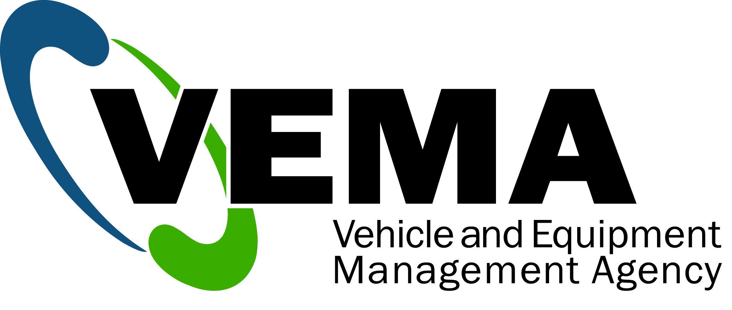

626 Henry Avenue, Winnipeg, Manitoba R3A 1P7

Phone: 1-800-363-6693 Fax: 204-957-1109

Copies of this form are available at [www.vema.gov.mb.ca](http://www.vema.gov.mb.ca)

Last Revision Date: June 26, 2013